Future of Education Equity Fund - Application completion checklist
This checklist has been developed to you to complete applications to the Future of Education Equity Fund accurately, to avoid delays in processing payments.
Applicant and dependent details
 | My child/children are in years P-12 and are attending one of the following schools:  - A primary School, high school, or college located in the ACT  - A preschool attached to an ACT Government run School led by a Principal  - CIT – my child/children are studying a year 10 or year 12 equivalent and of school age | ☐
 | My child/children’s school have the most up-to-date details in their records, i.e. our home address, caring arrangements, etc.  Note: If not, please contact your school and update your details. | ☐
 | I have my current bank account details ready to enter (BSB & Account Number). | ☐
I have a current Centrelink Health Care Card or Pensioner Concession Card
 | I have attached a copy of my Centrelink Health Care Card (HCC) or Pensioner Concession Card (PCC)? Please see below for examples of these cards.  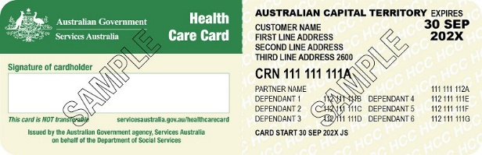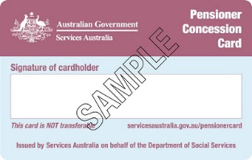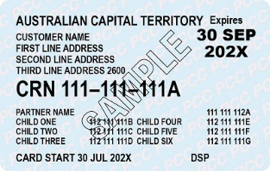 | ☐
 | My Centrelink HCC or PCC is current and for an income tested Centrelink payment?  Note: Cards endorsed ‘FO’, ‘CD’, ‘MO’, & ‘DSP Blind’ are not eligible. | ☐
 | All required details such as dependants, signature, expiry date, and endorsement code are visible on my Centrelink HCC or PCC? | ☐
 | The address on my Centrelink HCC or PCC matches the address on my application and my childs/children’s School Database? | ☐
I do not have a Centrelink Card
 | I have provided a copy of the following required financial evidence documents:  • Most recent Notice of Assessment from the Australian Tax Office.  • Payslips indicating your income for the past 8 weeks. | ☐
 | If I am living with my partner, I have provided financial evidence for myself and my partner.  The application will be assessed with using combined income for both partners. | ☐
 | I have provided proof of my address, e.g. driver licence or utility bill. | ☐

